Software Requirements Specifications

(Test Cases)

Version 1.0

Trip Planner

Team #7

|  |  |
| --- | --- |
| **Group Member Name** | **Roll number** |
| Oneeb | 15L-4350 |
| Syed Usama bin Jawad | 15L-4137 |
| Ali Nuaman | 15L-4264 |
| Ahmad Bilal | 15L-4243 |
| Abu Bakar Sohail | 15L-4155 |

Contents

1 Test Cases for Speech Input 5

1.1 TC-1 6

1.2 TC-2 7

2 Test Cases for Trip Creation 8

2.1 TC-3 9

2.2 TC-4 10

2.3 TC-5 11

2.4 TC-6 12

2.5 TC-7 13

3 Test Cases for Adding Friends 14

3.1 TC-8 15

3.2 TC-9 16

4 Test Cases for Removing Friend from Trip 17

4.1 TC-10 18

4.2 TC-11 19

5 View Trip History 20

5.1 TC-12 21

5.2 TC-13 22

**List of Figures**

|  |  |
| --- | --- |
| **Figure 1** | **Page 5** |
| **Figure 2** | **Page 8** |
| **Figure 3** | **Page 14** |
| **Figure 4** | **Page 17** |
| **Figure 5** | **Page 20** |

**List of Tables**

|  |  |
| --- | --- |
| **Table 1.1** | **Page 6** |
| **Table 1.2** | **Page 7** |
| **Table 2.1** | **Page 9** |
| **Table 2.2** | **Page 10** |
| **Table 2.3** | **Page 11** |
| **Table 2.4** | **Page 12** |
| **Table 2.5** | **Page 13** |
| **Table 3.1** | **Page 15** |
| **Table 3.2** | **Page 16** |
| **Table 4.1** | **Page 18** |
| **Table 4.2** | **Page 19** |
| **Table 5.1** | **Page 21** |
| **Table 5.2** | **Page 22** |

# Test Cases for Speech Input

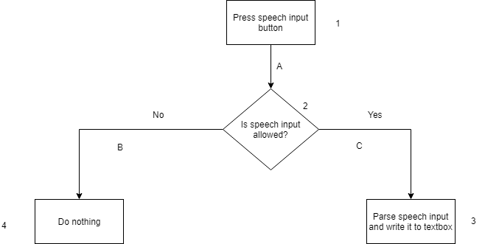

**Figure 1: Flowchart for Speech Input**

## TC-1

**Direction:** 1A-2C-3

**Statement coverage:** 75%

**Branch coverage:** 50%

**Path coverage:** 66%

**Loop boundary testing:** Not applicable

|  |  |
| --- | --- |
| **Identifier** | TC-1 |
| **Priority** | Low |
| **Short description** | This functionality allows user to enter the name of their planned trip using their device’s speech recognition tools and related software. |
| **Pre-condition(s)** | User has logged in to the system and has allowed the app to use his device’s voice recognition technology. |
| **Input data** | Speak “Test”. |
| **Detailed steps** | User presses the mic button next to the textbox in which he has to enter trip name. If permission to use voice recognition is allowed, the user will speak something, and two seconds after pausing, what he has spoken will be displayed in the textbox. |
| **Position in code** | Lines 189-201 and 212-230 in NewTripActivity.java |
| **Expected result(s)** | “Test” will be displayed in the textbox. |
| **Post-condition(s)** | “Test” is displayed in the textbox. |
| **Status** | PASS |

**Table 1.1: TC-1 (Speech Input)**

## TC-2

**Direction:** 1A-2B-4

**Statement coverage:** 75%

**Branch coverage:** 50%

**Path coverage:** 66%

**Loop boundary testing:** Not applicable

|  |  |
| --- | --- |
| **Identifier** | TC-2 |
| **Priority** | Low |
| **Short description** | This functionality allows user to enter the name of their planned trip using their device’s speech recognition tools and related software. |
| **Pre-condition(s)** | User has logged in to the system and has not allowed the app to use his device’s voice recognition technology. |
| **Input data** | Speak “Test”. |
| **Detailed steps** | User presses the mic button next to the textbox in which he has to enter trip name. If permission to use voice recognition is not allowed, the user will not be able to utilize it. |
| **Position in code** | Lines 189-201 and 212-230 in NewTripActivity.java |
| **Expected result(s)** | User will not be allowed to use speech recognition. |
| **Post-condition(s)** | User is not able to use speech recognition. |
| **Status** | PASS |

**Table 1.2: TC-2 (Speech Input)**

# Test Cases for Trip Creation

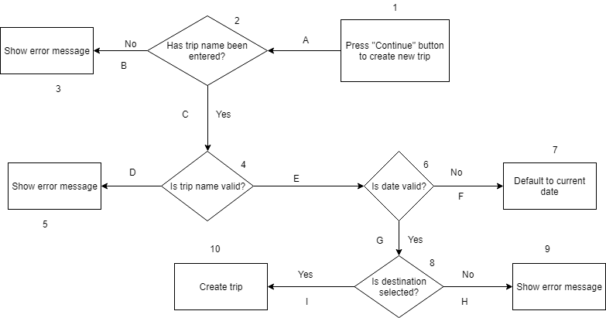

**Figure 2: Flowchart for Trip Creation**

## TC-3

**Direction:** 1A-2B-3

**Statement coverage:** 30%

**Branch coverage:** 12.5%

**Path coverage:** 22.2%

**Loop boundary testing:** Not applicable

|  |  |
| --- | --- |
| **Identifier** | TC-3 |
| **Priority** | High |
| **Short description** | This functionality allows user to create a new trip. |
| **Pre-condition(s)** | User has logged in to the app. |
| **Input data** | Leave trip name empty. |
| **Detailed steps** | User does not enter a trip name and just presses on the “Continue” button to create trip. |
| **Position in code** | Lines 232-287 in NewTripActivity.java |
| **Expected result(s)** | User will not be able to continue to the next page and will be prompted to enter trip name. |
| **Post-condition(s)** | User is not able to continue to the next page and is shown a toast notification to enter a trip name. |
| **Status** | PASS |

**Table 2.1: TC-3**

## TC-4

**Direction:** 1A-2C-4E-6F-7

**Statement coverage:** 50%

**Branch coverage:** 37.5%

**Path coverage:** 44.4%

**Loop boundary testing:** Not applicable

|  |  |
| --- | --- |
| **Identifier** | TC-4 |
| **Priority** | High |
| **Short description** | This functionality allows user to create a new trip. |
| **Pre-condition(s)** | User has logged in to the app and has entered a valid trip name. |
| **Input data** | Select a date prior to the current date. |
| **Detailed steps** | User uses the date picker to enter a date that has already passed and presses the “Continue” button. |
| **Position in code** | Lines 232-287 in NewTripActivity.java |
| **Expected result(s)** | User will not be able to continue to the next page. |
| **Post-condition(s)** | User is not able to continue to the next page, and the current date is set by default. |
| **Status** | PASS |

**Table 2.2: TC-4**

## TC-5

**Direction:** 1A-2C-4E-6G-8H-9

**Statement coverage:** 60%

**Branch coverage:** 62.5%

**Path coverage:** 50%

**Loop boundary testing:** Not applicable

|  |  |
| --- | --- |
| **Identifier** | TC-5 |
| **Priority** | High |
| **Short description** | This functionality allows user to create a new trip. |
| **Pre-condition(s)** | User has logged in to the app and has entered a valid trip name and date. |
| **Input data** | Do not select a trip destination. |
| **Detailed steps** | User does not use the map to select a trip destination and presses on the “Continue” button. |
| **Position in code** | Lines 232-287 in NewTripActivity.java |
| **Expected result(s)** | User will not be able to continue to the next page. |
| **Post-condition(s)** | User is not able to continue to the next page, and a toast notification is shown, prompting him to enter a trip destination. |
| **Status** | PASS |

**Table 2.3: TC-5**

## TC-6

**Direction:** 1A-2C-4D-5

**Statement coverage:** 40%

**Branch coverage:** 25%

**Path coverage:** 33.3%

**Loop boundary testing:** Not applicable

|  |  |
| --- | --- |
| **Identifier** | TC-6 |
| **Priority** | High |
| **Short description** | This functionality allows user to create a new trip. |
| **Pre-condition(s)** | User has logged in to the app. |
| **Input data** | Enter trip name as “123”. |
| **Detailed steps** | User enters the trip name as “123” in the associated textbox. |
| **Position in code** | Lines 232-287 in NewTripActivity.java |
| **Expected result(s)** | User will not be able to continue to the next page. |
| **Post-condition(s)** | User is not able to continue to the next page and is prompted to enter a trip name that does not start with a number. |
| **Status** | PASS |

**Table 2.4: TC-6**

## TC-7

**Direction:** 1A-2C-4E-6G-8I-10

**Statement coverage:** 60%

**Branch coverage:** 62.5%

**Path coverage:** 50%

**Loop boundary testing:** Not applicable

|  |  |
| --- | --- |
| **Identifier** | TC-7 |
| **Priority** | High |
| **Short description** | This functionality allows user to create a new trip. |
| **Pre-condition(s)** | User has logged in to the app. |
| **Input data** | Enter trip name = “Test”, date = “15th December 2018”, destination = “FAST-NUCES”. |
| **Detailed steps** | User enters all the aforementioned data and presses the “Continue” button. |
| **Position in code** | Lines 232-287 in NewTripActivity.java |
| **Expected result(s)** | User will not be able to navigate to the next page. |
| **Post-condition(s)** | User is able to navigate to the next page. |
| **Status** | PASS |

**Table 2.5: TC-7**

# Test Cases for Adding Friends

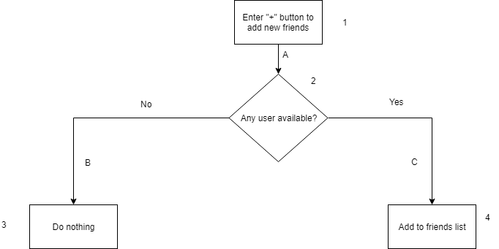

**Figure 3: Flowchart for Add Friends**

## TC-8

**Direction:** 1A-2C-4

**Statement coverage:** 66.6%

**Branch coverage:** 50%

**Path coverage:** 66.6%

**Loop boundary testing:** Not applicable

|  |  |
| --- | --- |
| **Identifier** | TC-8 |
| **Priority** | Medium |
| **Short description** | This functionality allows user to add new friends. |
| **Pre-condition(s)** | User has logged in to the app. |
| **Input data** | Select a name e.g.: “Usama” from the list of available friends. |
| **Detailed steps** | User selects a name from the list of available friends e.g.: “Usama”, and presses the “+” button. |
| **Position in code** | Lines 57-81 and 84-105 in NewTripBuddies.java. |
| **Expected result(s)** | “Usama” should be added to the list of friends. |
| **Post-condition(s)** | “Usama” is added to the list of friends. |
| **Status** | PASS |

**Table 3.1: TC-8**

## TC-9

**Direction:** 1A-2C-4

**Statement coverage:** 66.6%

**Branch coverage:** 50%

**Path coverage:** 66.6%

**Loop boundary testing:** Not applicable

|  |  |
| --- | --- |
| **Identifier** | TC-9 |
| **Priority** | Medium |
| **Short description** | This functionality allows user to add new friends. |
| **Pre-condition(s)** | User has logged in to the app and there are no friends remaining that can be added. |
| **Input data** | Select no name from the list of available friends. |
| **Detailed steps** | User presses the “+” button. |
| **Position in code** | Lines 57-81 and 84-105 in NewTripBuddies.java. |
| **Expected result(s)** | The current friends list should remain unchanged. |
| **Post-condition(s)** | The current friends list remains unchanged. |
| **Status** | PASS |

**Table 3.2: TC-9**

# Test Cases for Removing Friend from Trip

**Figure 4: Remove Friend from Trip**

## TC-10

**Direction:** 1A-2B-3C-4E-5

**Statement coverage:** 83.3%

**Branch coverage:** 50%

**Path coverage:** 80%

**Loop boundary testing:** Not applicable

|  |  |
| --- | --- |
| **Identifier** | TC-10 |
| **Priority** | Low |
| **Short description** | This functionality allows user to remove friends from upcoming trips. |
| **Pre-condition(s)** | User has logged in to the app and has selected an upcoming trip that he created. |
| **Input data** | Long press on your own username and select “remove”. |
| **Detailed steps** | User navigates to an upcoming trip and then his friends list, where he tries to remove himself from the trip. |
| **Position in code** | Spread throughout TripViewActivity.java |
| **Expected result(s)** | There should be no option displayed to remove oneself from trip. |
| **Post-condition(s)** | No option is shown to remove oneself from trip. |
| **Status** | PASS |

**Table 4.1: TC-10**

## TC-11

**Direction:** 1A-2B-3C-4D-6

**Statement coverage:** 83.3%

**Branch coverage:** 50%

**Path coverage:** 80%

**Loop boundary testing:** Not applicable

|  |  |
| --- | --- |
| **Identifier** | TC-11 |
| **Priority** | Low |
| **Short description** | This functionality allows user to remove friends from upcoming trips. |
| **Pre-condition(s)** | User has logged in to the app and has selected an upcoming trip that he created. |
| **Input data** | Long press on a friend’s username and select “remove”. |
| **Detailed steps** | User navigates to an upcoming trip and then his friends list, where he tries to remove a friend from the trip. |
| **Position in code** | Spread throughout TripViewActivity.java |
| **Expected result(s)** | The selected friend should be removed from the trip. |
| **Post-condition(s)** | The selected friend is removed from the trip and the count for number of friends of trip decreases. |
| **Status** | PASS |

**Table 4.2: TC-11**

# View Trip History

**Figure 5: Flowchart for View Trip History**

## TC-12

**Direction:** 1A-2B-3D-4

**Statement coverage:** 80%

**Branch coverage:** 50%

**Path coverage:** 75%

**Loop boundary testing:** Takes places on Node 2, which will be a self-loop, 50% coverage

|  |  |
| --- | --- |
| **Identifier** | TC-12 |
| **Priority** | High |
| **Short description** | This functionality allows user to view past trips. |
| **Pre-condition(s)** | User has logged in to the app. |
| **Input data** | No past trips in database. |
| **Detailed steps** | User navigates to trip history from navigation drawer. |
| **Position in code** | 10-51 in TripHistoryActivity.java |
| **Expected result(s)** | Nothing should be shown. |
| **Post-condition(s)** | No trips are shown. |
| **Status** | PASS |

**Table 5.1: TC-12**

## TC-13

**Direction:** 1A-2B-3C-5

**Statement coverage:** 80%

**Branch coverage:** 50%

**Path coverage:** 75%

**Loop boundary testing:** Takes places on Node 2, which will be a self-loop, 50% coverage

|  |  |
| --- | --- |
| **Identifier** | TC-13 |
| **Priority** | High |
| **Short description** | This functionality allows user to view past trips. |
| **Pre-condition(s)** | User has logged in to the app. |
| **Input data** | Greater than 0 trips in the database. |
| **Detailed steps** | User navigates to trip history from navigation drawer. |
| **Position in code** | 10-51 in TripHistoryActivity.java |
| **Expected result(s)** | Summary of past trips should be shown. |
| **Post-condition(s)** | Summary of past trips is shown. |
| **Status** | PASS |